**Cohort Details React App**

**REACT**

Vaishnavi

26/7/2025

This React application displays detailed information about training cohorts, including their technology, start date, coach, trainer, and current status. It showcases how to work with custom classes, modular CSS (.module.css), and data rendering using props and object-oriented JavaScript.

**Objective:**

* To dynamically display cohort data using React components and props.
* To implement conditional styling based on cohort status (e.g., Ongoing or Scheduled).
* To apply modular and reusable styles using CSS modules.
* To use class-based data modeling for better organization.

**Implementation:**

**Step 1: Extracting the zip file cohorttracker.zip**

**Step 2: Navigating to the folder in VS Code**



**Step 3: Reinstalling the packages**



**Step 4: Create the CSS Module**

**CohortDetails.module.css**

.box {

width: 300px;

display: inline-block;

margin: 10px;

padding: 10px 20px;

border: 1px solid black;

border-radius: 10px;

}

dt {

font-weight: 500;

}

**Step 5: Create the CohortDetails Component**

**CohortDetails.js**

import React from 'react';

import styles from './CohortDetails.module.css';

function CohortDetails({ cohort }) {

// Inline style for h3 based on cohort status

const headingStyle = {

color: cohort.status === 'ongoing' ? 'green' : 'blue'

};

return (

<div className={styles.box}>

<h3 style={headingStyle}>{cohort.name}</h3>

<dl>

<dt>Status:</dt>

<dd>{cohort.status}</dd>

<dt>Start Date:</dt>

<dd>{cohort.startDate}</dd>

<dt>End Date:</dt>

<dd>{cohort.endDate}</dd>

</dl>

</div>

);

}

export default CohortDetails;

**Step 6: Render the Cohorts in App.js**

**App.js**

import React from 'react';

import CohortDetails from './CohortDetails';

function App() {

const cohorts = [

{ name: 'React Bootcamp', status: 'ongoing', startDate: '2025-07-01', endDate: '2025-07-30' },

{ name: 'Java Fundamentals', status: 'completed', startDate: '2025-06-01', endDate: '2025-06-30' }

];

return (

<div className="App">

<h1>Cohort Dashboard</h1>

{cohorts.map((cohort, index) => (

<CohortDetails key={index} cohort={cohort} />

))}

</div>

);

}

export default App;

**Step 7: Run the App**



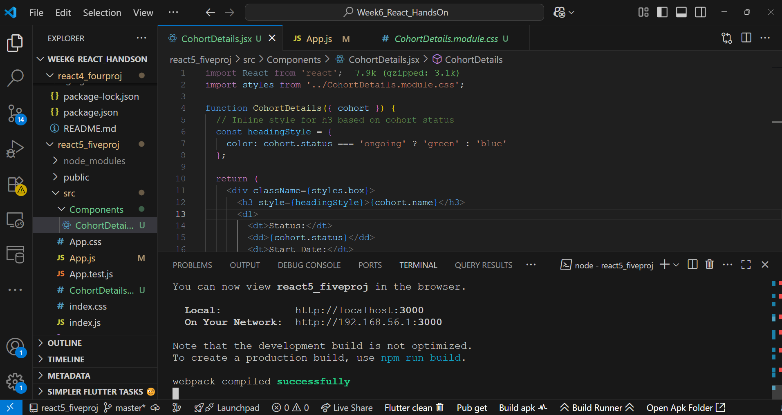

**Output:**

